**UNIT 2**

**Software Requirements Specification**

**for**

**Security satellite tracking for public and private service**

**Version 1.0 approved**

**Prepared by Teams 4 - WOLVES**

DOMENICA MONTSERRAT PADILLA ANDRANGO

DIEGO ARMANDO PONCE ARGUELLO

ELKIN ANDRES PABON GONZALEZ

JERSON ALEXIS POZO MONTALUISA

STEVEN DAVID PACHECO DE LA TORRE

PhD. Edison Lascano

December 09, 2021

Software Engineering

Software engineering fundamentals

**Table of Contents**

**Table of Contents........................................................................................................................... ii**

**Revision History............................................................................................................................. ii**

**1.Introduction.......................................................................................................................... 1**

**1.1 Purpose.............................................................................................................................. 1**

**1.2 Document Conventions..................................................................................................... 1**

**1.3 Intended Audience and Reading Suggestions.............................................................. 1**

**1.4 Product Scope.................................................................................................................. 1**

**1.5 References........................................................................................................................ 1**

**2. Overall Description........................................................................................................... 2**

**2.1 Product Perspective......................................................................................................... 2**

**2.2 Product Functions........................................................................................................... 2**

**2.3 User Classes and Characteristics................................................................................... 2**

**2.4 Operating Environment.................................................................................................. 2**

**2.5 Design and Implementation Constraints....................................................................... 2**

**2.6 User Documentation........................................................................................................ 2**

**2.7 Assumptions and Dependencies..................................................................................... 3**

**3. External Interface Requirements..................................................................................... 3**

**3.1 User Interfaces................................................................................................................. 3**

**3.2 Hardware Interfaces....................................................................................................... 3**

**3.3 Software Interfaces......................................................................................................... 3**

**3.4 Communications Interfaces............................................................................................ 3**

**4. System Features................................................................................................................. 4**

**4.1 System Feature 1............................................................................................................. 4**

**4.2 System Feature 2 (and so on).......................................................................................... 4**

**5. Other Nonfunctional Requirements................................................................................ 4**

**5.1 Performance Requirements............................................................................................ 4**

**5.2 Safety Requirements....................................................................................................... 5**

**5.3 Security Requirements.................................................................................................... 5**

**5.4 Software Quality Attributes........................................................................................... 5**

**5.5 Business Rules.................................................................................................................. 5**

**6. Other Requirements.......................................................................................................... 5**

**Appendix A: Glossary............................................................................................................. 5**

**Appendix B: Analysis Models................................................................................................ 5**

**Appendix C: To Be Determined List..................................................................................... 6**

**Revision History**

| **Name** | **Date** | **Reason For Changes** | **Version** |
| --- | --- | --- | --- |
|  | **10/12/2021** |  |  |
|  |  |  |  |

**1. Introduction**

**1.1 Purpose**

In this project, the construction of a web platform is proposed that allows us to monitor the vehicle through a GPS tracking device, it will allow us to locate, monitor and block the vehicle in real time.

**1.2 Document Convention**

The execution of the services provided by the administration, control, follow-up and monitoring application will be carried out from the device that the user has available, since each user will have a profile to carry out their monitoring

**1.3 Intended Audience and Reading Suggestions**

With Securitrac- Rastreo Satelital, you will have administrative resources that will allow you to know:

* The location of your vehicle
* Driving speed
* Stops and routes
* Fuel consumption
* Performance activity of the driver and consequently of the vehicle

**1.4 Product Scope**

Mainly to the vehicle sales sector in companies for both private and public service and also as a private user

**1.5 References**

[1] «¿Cómo funciona el sistema de rastreo satelital GPS? - Securitrac», *Securitrac Rastreo satelital*. https://www.securitrac.net/index.php/como-funciona-el-rastreo-satelital/ (accedido dic. 09, 2021).

[2] «Rastreo satelital para gobierno», *Magnitracking*. https://www.magnitracking.com/rastreo-satelital-para-gobierno/ (accedido dic. 09, 2021).

[3] Universidad Nacional de Colombia *et al.*, «Analysis of requirements for secure automated vehicle location devices for public transportation systems in Colombia», *Ing. Desarro.*, vol. 36, n.o 2, pp. 298-326, jul. 2018, doi: 10.14482/inde.36.2.10037.

**2. Overall Description**

**2.1** Product Perspective

The application must be an attractive and cheerful application, without neglecting formality, seeking to be intuitive for the easy use of the application for all users.

**2.2** Product Functions

The product will be able to perform different actions to guarantee the safety of the user, this being as

Satellite tracking.

Joint collaboration with the police.

Total audio recording during the trip

This and more are actions that will be carried out to guarantee user safety.

**2.3** User Classes Characteristics

Those people who have the need to carry out the mobilization of this type, who seek greater security and want to use this transport.

**2.4** Operating Environment

It will work on the Android platform, a correlation must be made with the satellite tracking and recording systems, acquisition of permits and access to the specific telephone in order to carry out the development.

Se trabajará en plataforma Android, se deberá realizar una correlación con los sistemas de rastreo satelital y de grabaciones, adquisición de permisos y accesos al teléfono específico para poder realizar el desarrollo.

**2.5** Design and Implementation Constraints

Limitations are needed with the support of the national police to attend to the help of the different users, there could also be problems with people's acceptance of the terms when using the application, giving limitations such as not accepting the constant recording of the trip, or the sharing of location, etc.

**2.6** Design and Implementation Constraints

An initiation of the software will be carried out with a tutorial on the use of the application in addition to this, the user manual will be available at all times, all the user documentation will have access to the managers and owners of the application as well as the engineers who created the application.

**2.7** Assumptions and Dependencies

Developed to work in the public transport area, considering that people from any sector with coverage can work here. In the event that the company expands, then it will be necessary to modify the relevant requirements. In this case, it will be necessary to add greater coverage areas in order to expand the use of the application without any problem, as well as requirements regarding new users that may arise.

**3. External Interface Requirements**

**3.1** **User Interfaces**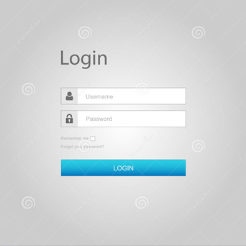

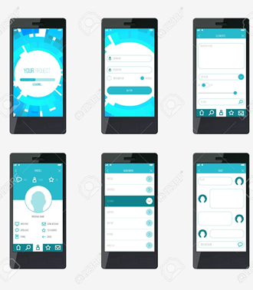

**3.2** **Hardware Interfaces**

As previously mentioned, the user of our service must have the implements in their car which will have a code that must be registered on the platform to confirm its use for safety.

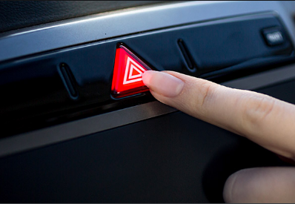

One of them is an alarm button which will be for the use of the client, this button will alarm the software provider which will have the necessary measures to handle the situation.

**3.3** **Software Interfaces**

For our application we will be based on existing databases of applications such as uber, traceus or waze

For the start and close of the session the following was used:

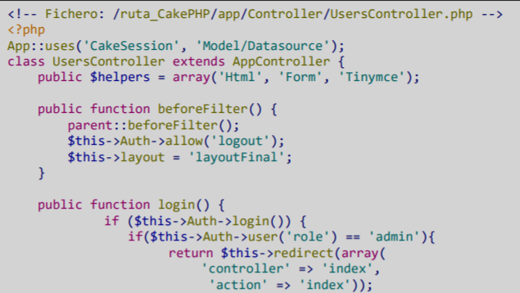

For the security of individual users, especially the following will be used that will allow the location only if the application is open:

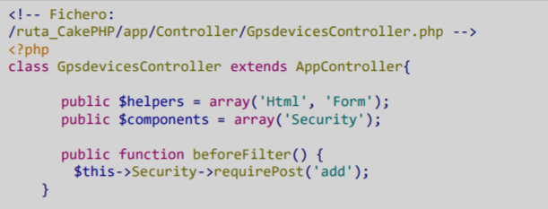

Since the application is still in the process of creation, there is no email or a web browser through which the client can be helped, but it will be added on the day of its launch.

FTP will be used as it is the set of rules that devices on a TCP / IP network (Internet) use to transfer files. When you use the Internet, you actually use a variety of different protocols.

Also in case of an error, the user will be notified with the following messages:

Incorrect username or password.

Required field: In case of not filling in a mandatory data box

Unavailable / Timed Out: In the event of a customer unavailable or page delay.

Off route: In case the user goes off the indicated route.

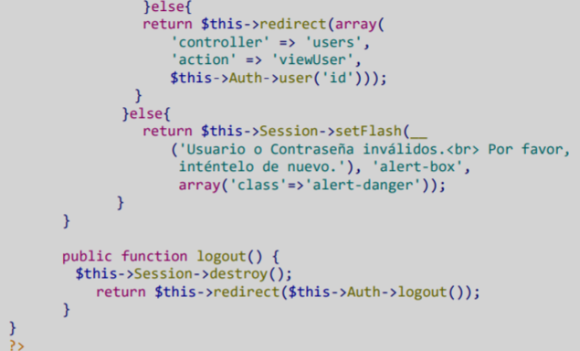

# 

# **4. System Features**

### ***Functional Requirements***

### **Log in**

| Use Case Name: | Log in | | | |
| --- | --- | --- | --- | --- |
| Identifier | REQ-01 | | | |
| Description | The user will be able to access the application through a username and password created when the tracking device is installed in the vehicle. | | | |
| Goal | The user will have to enter their credentials and their required personal information. | | | |
| Status: | - | | Version: | 1.0 |
| Autor: | Group | | | |
| Creation date | *8/12/2021* | | Modified date | *10/12/2021* |
| Pre conditions | The application must have the customer's data and username and password registered with all their personal data for a better experience. | | | |
| **Basic flow**  The password and the user are entered, the application validates the entered data and if they are correct it allows access to the system. | | | | |
| Actor | | System | | |
| *User* | | 1. Enter Password and Username.  2. Validation of entered data.  3. Access to the system. | | |
| **Alternative Flow** | | | | |
| If the customer does not appear in the application data, the option to contact customer service to solve the problem will be presented. | | | | |
| Post conditions:  By entering the application, the user will be able to access all the features of the satellite tracking service. | | | | |

* **Customer Registration**

| Use Case Name: | Customer Registration | | | |
| --- | --- | --- | --- | --- |
| Identifier | REQ-02 | | | |
| Description | The application will store user information in the database. | | | |
| Goals | Register the customer in the system | | | |
| Condition: | - | | Versión: | 1.0 |
| Autor: | Jerson Pozo, Elkin Pabon, David Pacheco, Dominica Padilla, Diego Ponce | | | |
| Creation date | *8/12/2021* | | Fecha modificación | *10/12/2021* |
| Frequency | Every time a new user is going to access the system for the first time. | | | |
| Pre conditions | Have the permissions and credentials generated by the administrators of the satellite tracking system. | | | |
| Actor | | System | | |
| 1. The customer enters the application.      1. The client chooses the option to register            1. The client enters all the required data.          1. The customer enters the confirmation code sent to his cell phone number. | | 1. The application will show the option of Login, Register and Technical Service.  2. The application will show the data that the user must enter: Full Names, Identification Number, Cellular Number, Email, Credential generated by the service administrator, Username, Password, Retype the Password. At the end there will be a button that says: "Register".  3. The system saves the created user in its database and requests a confirmation of identity by sending a 4-digit code (numbers and letters) to the cell phone number that the user must enter to complete their registration correctly.  4. The application will complete the registration and allow the user to access all its functions. | | |
| **Alternative Flow** | | | | |
| 1. The user does not have the credentials generated by the service administrator.  The application will display a message that says "Contact Technical Service to solve your problem."  2. The user enters invalid characters or incorrect data in the different options.  The application will show a message that says "Invalid data, write it correctly".  3. The user does not receive the confirmation message on his cell phone to complete his registration.  The application will show three options: 1) Resend confirmation code. 2) Change cell phone number. 3) Technical Service.  4. The user enters invalid characters when writing the confirmation code.  The application will show a message that says "Invalid data, write it correctly". | | | | |
| Post conditions:  • The application displays a confirmation message of the successful registration.  · The user can log into the system using his identification number and the password created by him. | | | | |
| Use cases included: Login | | | | |
| Extended use cases: None | | | | |

**Real-time data for the user**

| Use Case Name: | Data in the application | | | |
| --- | --- | --- | --- | --- |
| Identifier | REQ-03 | | | |
| Description | The application will show all the information of the customer's vehicle in real time divided into several options to choose from. | | | |
| Goal | The user accesses all the information of his vehicle. | | | |
| Status: | - | | Version: | 1.0 |
| Autor: | Jerson Pozo, Elkin Pabon, David Pacheco, Dominica Padilla, Diego Ponce | | | |
| Creation date | *8/12/2021* | | Modified date | *10/12/2021* |
| Pre conditions | The user must be registered and logged into the application. | | | |
| **Basic flow**  The application is accessed and all the options to choose from are displayed in the menu. | | | | |
| Actor | | System | | |
| *User* | | 1. Enter the application.  2. Login with your data.  3. Choose the option you require from the menu. | | |
| **Alternative Flow** | | | | |
| If no option is displayed, the user must check if his account is correctly configured or contact the technical service. | | | | |
| Post conditions:  By choosing the option that the client requires, he will be able to have information about the use of his vehicle. | | | | |

**Vehicle remote control system**

| Use Case Name: | Vehicle remote control system | | | |
| --- | --- | --- | --- | --- |
| Identifier | REQ-04 | | | |
| Description | The application gives the option to control vehicle options such as: Alarm, locking and opening the car doors, turning the engine on and off in an emergency, locking the engine and activating a panic button. | | | |
| Goal | The user can control the basic functions of the vehicle from the application. | | | |
| Status: | - | Version: | | 1.0 |
| Autor: | Jerson Pozo, Elkin Pabon, David Pacheco, Dominica Padilla, Diego Ponce | | | |
| Creation date | *8/12/2021* | Modified date | | *10/12/2021* |
| Pre conditions | The user must be logged into the application. | | | |
| **Basic flow**  The user enters the application and selects one of the options that the application has. | | | | |
| Actor | | | System | |
| 1. The user accesses the application with his account.  2. The user chooses the option he needs.  3. The user confirms the execution of the option he chose. | | | 1. The application displays all the options to choose from.  2. The application asks the user to confirm the action to be taken for security reasons.  3. The application sends the order to be carried out to the vehicle and the vehicle executes it. | |
| **Alternative Flow** | | | | |
| If the selected option is not executed in the vehicle, it should be verified if the system is properly installed and connected by calling technical service. | | | | |
| Post conditions:  Choosing the required option, the vehicle will fulfill the order given by the user. | | | | |

**5. Other Nonfunctional Requirements**

**5.1** Performance Requirements

1. Speed: the system must maintain a continuous signal and avoid getting lost and be strong.
2. Efficiency: the system must comply with all security protocols for its approval for use.
3. Availability: the system must be available at any time 24 hours a day and every day.
4. Accuracy: the system must work correctly and in real time.
5. Performance: the system must be updated for proper performance.
6. Response time: the system must display responses to the required information in the time requested by the user.

**5.2** Safety Requirements

In case of system problems

* The user must report through the support page of the company his problem with the application.
* The user must avoid using the application until the problem is solved.
* The user must update his data and information.
* The user must read the privacy policy of the application and proceed with the steps to follow.

**5.3** Security Requirements

* The user must log in to the application with the correct username and password.
* The user must accept the terms and conditions.
* The user must allow real time location of his device.
* The user must verify that the driver of the requested vehicle also meets the requirements to start the trip.

**5.4** Software Quality Attributes

* This application is adapted to any device with any operating system.
* The software used does not require much space in the memory of the mobile phone.
* The application has virtual support which will help you to solve or answer any inconvenience.

**5.5** Business Rules

* Online help: the application has professionals trained to answer or solve any inconvenience.
* Assistants and agents: in case of technical problems that cannot be solved through the online support there are assistants that will help us when we approach the company.
* User documentation: this information is at home in the application where you can find the history of your trips, personal data.

**6. Other Requirements**

Language: the system must have different types of languages for different users of different nationalities.